Authoring App Requirements Document

*EECS 2311: Software Engineering Project*

*Team 9*

*December 4, 2017*

**Authors**

Jeremy Winkler

Nisha Sharma

Tyler Thomson

|  |  |  |  |
| --- | --- | --- | --- |
| **Revision Level** | **Date** | **Pages affected** | **Comments** |
| 1.0.0 | February 23, 2018 | 1-7 | Midterm Submission |
| 1.0 | February 05, 2018 | 1 | Initial draft |

# **Table of Contents**

Table of Contents

List of Figures

1.0 Introduction

2.0 Requirements

2.1 Key Requirements:

2.1 User Requirements:

2.2 System Requirements:

3.0 Use Case

3.1 Textual Use Case

3.1 Use Case Diagram

Figure 1. Use case for Authoring App

4.0 Acceptance Test Case

5.0 References

# **List of Figures**

Figure 1. Use case for Authoring App 5

# 

# **1.0 Introduction**

This document specifies the required features of the scenario creator Authoring App software. The Authoring App software allows educators to create, save, edit and test educational scenarios for visually impaired users. The program is capable of accepting text inputs and audio files of “.wav” format for creating interactive scenarios. The program also allows educators to record and save new audio files. Current version just allows to play audio in record mode after saving the file, however final version will have a play feature allowing to play selected audio files. By following the simple input syntax, the educators can create educational scenarios and save them as “.txt” files. This document list the requirements, acceptance tests, use cases:

# **2.0 Requirements**

This section describes what the Authoring App software system does for the client. These requirements have been derived by interviewing the client.

## **2.1 Key Requirements:**

Here are the key requirements as requested by the client.

|  |  |  |
| --- | --- | --- |
| **Requirement Number** | **Brief Description** | **Comments and Rationale** |
| R1 | Software should allow the users to create the flow of scenarios (ask questions, receive answers) | The users should be able to add a prompt/question and should also be able to receive a response/answer in a flow. |
| R2 | Software should allow the users edit scenarios | The users should be able to edit a previously created and saved scenario anytime. The users should also be able to save those changes. |
| R3 | Software should allow the users to record audio in .wav format | The users should be able to record audio and save it in .wav format to be inserted in scenario file. |
| R4 | Software should allow the users to test/play scenarios. | The users should be able to test/play their saved scenarios (before potentially handing them over to their students). |

## **2.1 User Requirements:**

Following is an important user requirement for the Authoring App.

|  |  |  |
| --- | --- | --- |
| **Requirement Number** | **Brief Description** | **Comments and Rationale** |
| R5 | The Authoring App must be usable by visually-impaired users | The authoring app should be accessible and user-friendly for visually impaired users. The assumption is that those users have screen reader software installed on their devices and know how to interact with it. |

## **2.2 System Requirements:**

Following is the system requirements for successfully running the Authoring App.

|  |  |  |
| --- | --- | --- |
| **Requirement Number** | **Brief Description** | **Comments and Rationale** |
| R6 | The Authoring App should be able to run successfully on Windows, Linux and Mac operating systems. | The authoring app should be fully functional on at-least two of the operating systems. |

# **3.0 Use Case**

This section includes a simple use case of the Authoring App. Below is the textual use case

## **3.1 Textual Use Case**

1. **Launch** the Authoring App
2. **Create** a **New** Scenario
3. **Save** the Scenario
4. **Edit** the saved scenario
5. **Save** the scenario
6. **Test/Play** the saved scenario
7. **Exit** the Authoring App

## **3.1 Use Case Diagram**

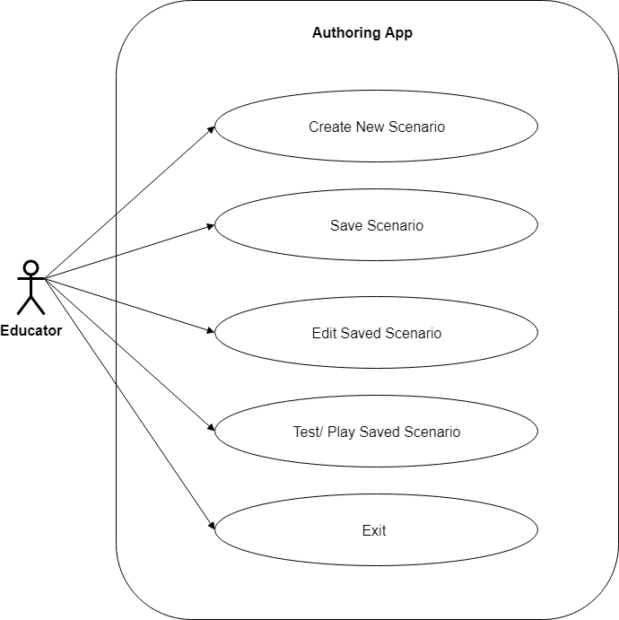

### **Figure 1.** Use case for Authoring App

# **4.0 Acceptance Test Case**

This section list the acceptance tests (performed by users to test the real life use of the app).

1. User should be able to save the scenario files in .txt format, as it is the format required to run test simulator for Treasure Box Brail (TBB). The saved version should have respective markers as described in Scenario File Format Documentation. [1]
2. User should be able to load a properly formatted scenario ‘.txt’ file in the authoring app to edit different components associated with it.
3. User should be able to insert audio files of ‘.wav’ format in the scenario. This audio would be played while running test simulator.
4. User should be able to record new audio files and save them in ‘.wav’ format.
5. User should be able to raise pins particular pin on braille cell in TBB simulator.
6. User should be able to specify finite number of cells and buttons for a particular scenario on creation.
7. User should be able to ask a question and receive a response in terms of button clicks.
8. User should be able to associate a sound file and text feedback with each button click.
9. User should be able rearrange the order of different question and response segments of scenario.
10. User should be able to successfully test a saved scenario file with TBB simulator.

# **5.0 References**

[1] B. Tzerpos,“Scenario File Format Documentation” *EECS 2311 – Software Development Project*, <https://wiki.eecs.yorku.ca/course_archive/2017-18/W/2311/_media/scenarioformat.pdf>. [Accessed: 21- Jan- 2018].